**WEEK -6**

1. **Problem Statement**: Write a C for the implementation of FIFO.

// The code for writing in the file myfifo.

#include <stdio.h>

#include <string.h>

#include <sys/stat.h>

#include <fcntl.h>

int main() { int fd , numberOfBytes ; char str[100];

mknod("myfifo" , S_IFIFO| 0666 , 0); fd = open("myfifo" , O_WRONLY); printf ("Writing in the fifo : \n");

while (fgets(str, sizeof(str), stdin)){

numberOfBytes = fwrite(fd , str , strlen(str));

printf ("Writer process writes %d bytes : %s\n" , numberOfBytes , str);

}

return 0;

}

// The code for reading in the file myfifo.

#include <stdio.h>

#include <string.h>

#include <unistd.h>

#include <sys/stat.h>

#include <fcntl.h>

int main(){

int numberOfBytes , fd ; char arr[100];

mknod("myfifo" , S_IFIFO|0666 , 0); int fd = open("myfifo" , O_RDONLY);

do{

numberOfBytes = read(fd , arr , sizeof(arr)); arr[numberOfBytes] = '\0';

printf("Reader process reads %d bytes : %s\n" , numberOfBytes , arr);

}while (numberOfBytes > 0 );

return 0;

}

**OUTPUT**

* **Writer Terminal**

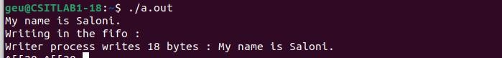

* **Reader Terminal**

